[MAP](https://www.google.cz/maps/search/Hotely/@50.0818558,14.420949,16.5z/data=!4m7!2m6!5m4!5m2!1s2019-05-12!2i2!10e3!6e3?hl=cs&authuser=0) - accommodation

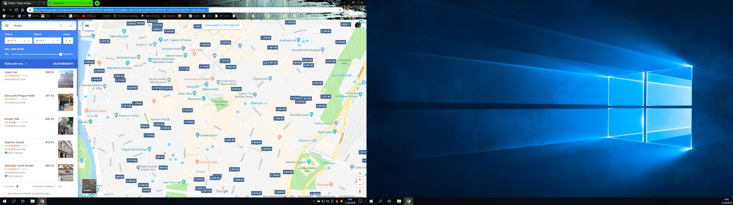

[MAP](https://www.google.cz/maps/search/Restaurace/@50.0800845,14.4197138,17.5z/data=!4m2!2m1!6e5?hl=cs&authuser=0) – restaurants

* 